

FACULTY OF TECHNOLOGY AND ENGINEERING DEVANG PATEL INSTITUTE OF ADVANCE TECHNOLOGY AND RESEARCH

DEPARTMENT OF COMPUTER ENGINEERING

A.Y 2026 – 27
Semester – 3

LAB MANUAL

CSUC201 Fundamentals of Data Structures and Algorithms



Practical 8: Binary Tree Traversals and Binary Search Tree Insertion

Practical Aim:
To implement binary tree traversals and binary search tree insertion, and develop the ability to reason about how the order of visiting nodes changes the information retrieved from a tree.

Problem 1
A company stores its organizational hierarchy as a tree — the CEO at the top, managers below, and employees at the leaves. Different departments need the hierarchy printed in different orders: HR wants each manager printed between their left and right sub-teams, the archive department wants each manager printed before their sub-teams, the payroll department wants each manager printed after all their sub-teams are listed, and the floor manager wants everyone printed level by level from top to bottom. Given a binary tree representing the hierarchy, implement all four printing orders and display the result of each. Describe how your solution for level-by-level printing differs from the other three. What additional structure did you need to use, and why does the same recursive approach that works for the other three not directly apply here?

Link:

Output:

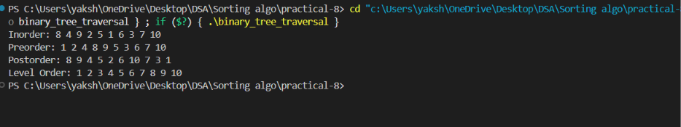

Outcome/Conclusion:
Learned the structural differences between Depth-First Search (inorder, preorder, postorder using recursive stacks) and Breadth-First Search (level-order using a FIFO queue), and practically applied them to extract data in specific hierarchical sequences.

Problem 2
A school library uses a system where every book is assigned a unique code when it arrives. Books are organized so that at any shelf position, all books to the left have smaller codes and all books to the right have larger codes. This arrangement lets staff find any book quickly by always knowing which direction to look. Given a sequence of book codes arriving one by one, insert each into the correct position and print the inorder sequence after all insertions are complete. Describe how your solution decides where to place each new book code. What
property of the final inorder sequence tells you whether all insertions were performed correctly?

Link:

Output:

Outcome/Conclusion:

Learned how to practically implement a Binary Search Tree (BST) by writing recursive insertion logic that dynamically maintains a "left-smaller, right-larger" property, and proved that an inorder traversal naturally extracts that data in sorted order.

Key Questions / Analysis / Interpretation to be Evaluated During/After Implementation

[Problem 1] Preorder traversal always visits the root before anything else. Using only this property — without tracing any tree — explain whether it would be possible to reconstruct the original tree from its preorder output alone, and what additional information you would need if it is not.

ANSWER
Tree Reconstruction No, it is not possible to reconstruct the original tree from just the preorder output. While you know the first element is the root, you have no way to know where the left subtree's elements end and the right subtree's elements begin. To uniquely reconstruct the tree, you would need additional information, most commonly the Inorder traversal output, which clearly defines the left-right boundaries around the root.

[Problem 2] The inorder traversal of a correctly built BST always produces a sorted sequence. If your inorder output is not sorted after all insertions, what does that tell you about where the error is — in the insertion logic, the traversal logic, or possibly both? How would you isolate which one?

ANSWER

Isolating the Error The error could be in the insertion logic, the traversal logic, or both. To isolate the issue, you should print the tree using a different traversal (like Level-order or Preorder) to visually inspect the structure.
If the tree structure perfectly follows BST rules (left is smaller, right is larger), the traversal logic is broken. If the tree structure violates BST rules, your insertion logic is placing nodes incorrectly.

